**SAM-Portal**

**----------------------------------------------------------------------**

## **Objective-**

“The objective of the system is to automate the process of transferring data from an Excel sheet

to Things Board, where devices are created with specific keys and values. This data is then

displayed on a dashboard, allowing users to easily monitor and manage devices in a visual

format.”

# **System Overview-**

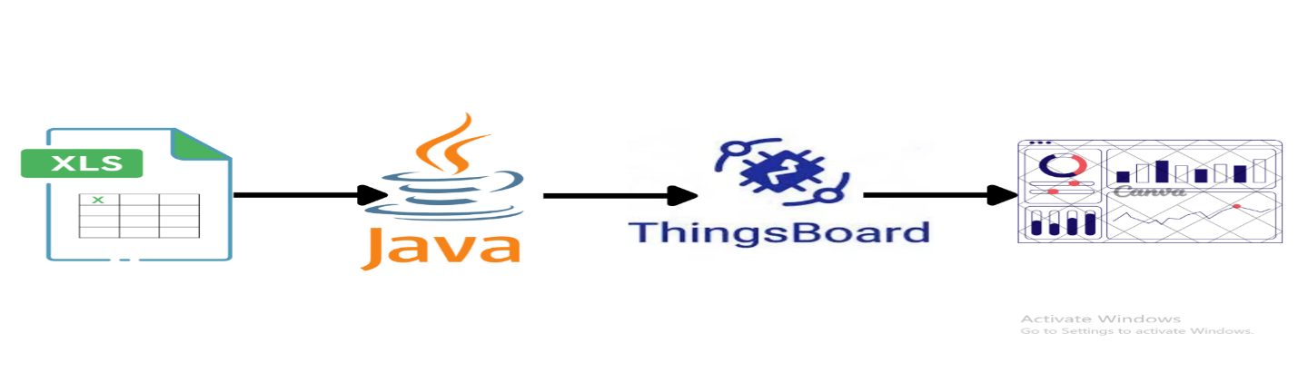**Benefits-**

* **Efficiency**: Reduces manual effort by automating data transfer.
* **Accuracy**: Ensures accurate data mapping between Excel and ThingsBoard.
* **Flexibility**: Allows easy addition or modification of devices through configuration files.
* **Enhanced Monitoring**: Provides dashboards for device management.

# **Conclusion-**

This system bridges the gap between data collection via Excel and visualization via ThingsBoard using MQTT. By using Spring Boot-java, MQTT, and ThingsBoard, it offers automated solution for IoT device telemetry management. It also provide the dashboard for visualization the devices.